**Lab Exercise 5- Understanding CMD, RUN, and ENTRYPOINT in Dockerfile**

**Objective:**

To learn the differences between CMD, RUN, and ENTRYPOINT instructions in Dockerfiles by creating and running Docker containers with different configurations.

**Prerequisites:**

* Docker installed on your machine
* Basic understanding of Docker and Dockerfile

**Part 1: Overview of CMD, RUN, and ENTRYPOINT**

* **RUN:** Executes commands at build time to install software, download dependencies, or configure the environment. The result is saved in the image.
* **CMD:** Specifies the default command to be executed when a container starts. It can be overridden when running a container.
* **ENTRYPOINT:** Defines the main executable for the container, which can't be easily overridden. However, additional arguments can be passed when the container starts.

**Part 2: Exploring RUN Command**

1. **Create a Dockerfile with RUN:**

Create a directory called dockerfile-run-cmd-entrypoint and navigate to it:

mkdir dockerfile-run-cmd-entrypoint && cd dockerfile-run-cmd-entrypoint

Create a simple Dockerfile that uses the RUN instruction:

# Use an official Ubuntu base image

FROM ubuntu:20.04

# Update the package repository and install curl

RUN apt-get update && apt-get install -y curl

# Print the version of curl

RUN curl --version

1. **Build the Docker Image:**

Build the image using the Dockerfile:

docker build -t run-example .

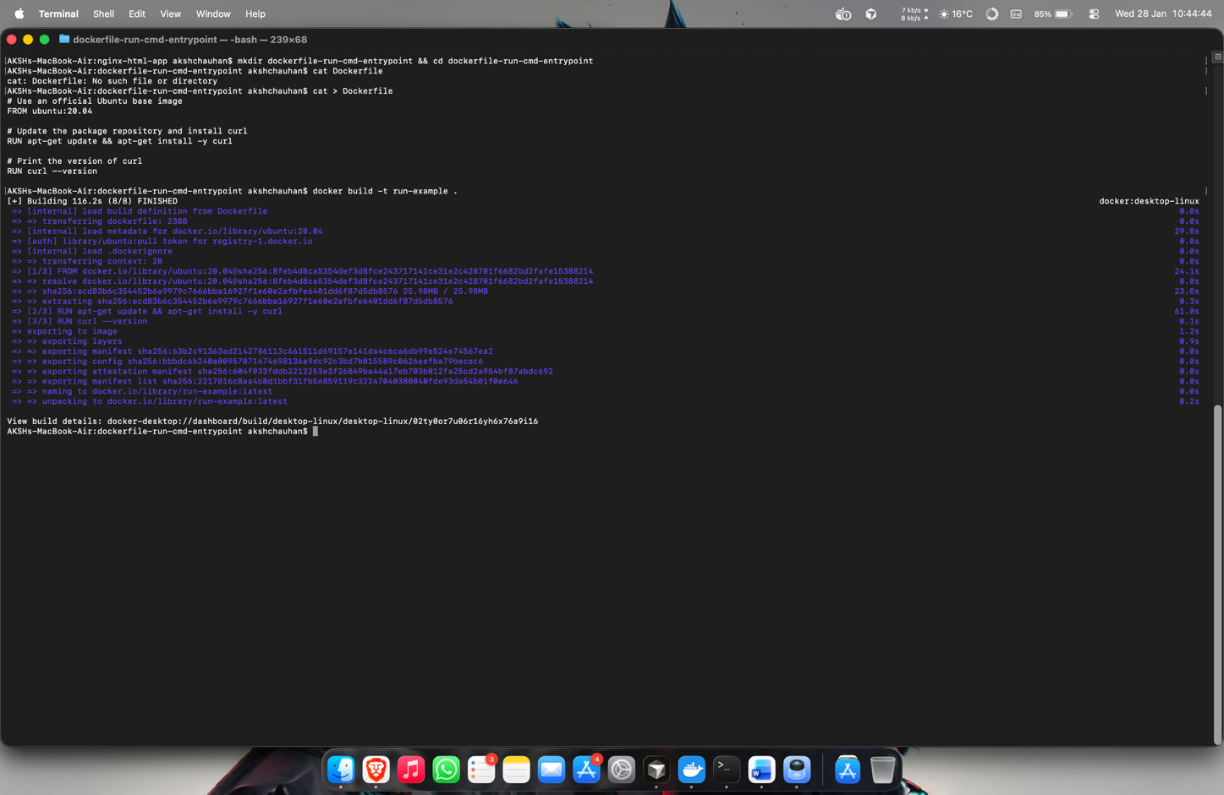

1. **Explanation:**

The RUN commands in this Dockerfile are executed during the image build process. The first RUN installs curl, and the second RUN command checks and prints the curl version. After the image is built, the commands executed by RUN are already baked into the image.

1. **Verify with Docker History:**

You can check the layers created by RUN using:

docker history run-example

Each RUN command creates a new layer in the image.

**Part 3: Exploring CMD Command**

1. **Create a Dockerfile with CMD:**

Modify the Dockerfile to include the CMD instruction:

# Use an official Ubuntu base image

FROM ubuntu:20.04

# Install curl

RUN apt-get update && apt-get install -y curl

# Set default command to display the curl version

CMD ["curl", "--version"]

1. **Build the Docker Image:**

Build the Docker image again:

docker build -t cmd-example .

1. **Run the Container:**

Run the container and see the output:

docker run cmd-example

The output will display the curl version as the default command defined by CMD is executed when the container starts.



1. **Override CMD:**

You can override the CMD by specifying a different command when you run the container:

docker run cmd-example echo "Hello from CMD!"

This will print Hello from CMD!, showing that the CMD can be overridden at runtime.



**Part 4: Exploring ENTRYPOINT Command**

1. **Create a Dockerfile with ENTRYPOINT:**

Modify the Dockerfile to use ENTRYPOINT instead of CMD:

# Use an official Ubuntu base image

FROM ubuntu:20.04

# Install curl

RUN apt-get update && apt-get install -y curl

# Set entrypoint to curl command

ENTRYPOINT ["curl"]

1. **Build the Docker Image:**

Build the image with the ENTRYPOINT instruction:

docker build -t entrypoint-example .

1. **Run the Container:**

When you run the container, since ENTRYPOINT is set to curl, you need to provide arguments to the curl command:

docker run entrypoint-example --version

This will print the curl version because ENTRYPOINT defines the main executable (in this case, curl) and --version is passed as an argument to curl.



1. **Override ENTRYPOINT:**

Unlike CMD, the ENTRYPOINT is not easily overridden. If you try to override it using:

docker run entrypoint-example echo "Hello from ENTRYPOINT!"

It will result in an error because curl will interpret echo as an argument.

However, you can use the --entrypoint option to change the entrypoint:

docker run --entrypoint /bin/bash entrypoint-example -c "echo Hello from ENTRYPOINT!"

This runs the container with /bin/bash as the entrypoint, overriding the default ENTRYPOINT.

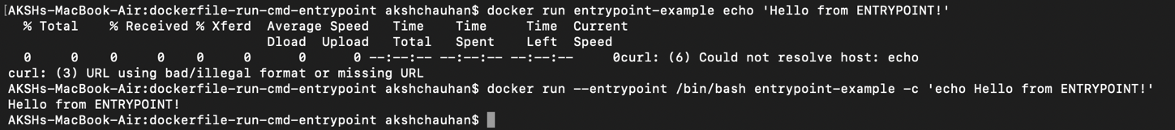

**Part 5: Combining CMD and ENTRYPOINT**

1. **Create a Dockerfile with Both CMD and ENTRYPOINT:**

Modify the Dockerfile to use both CMD and ENTRYPOINT:

# Use an official Ubuntu base image

FROM ubuntu:20.04

# Install curl

RUN apt-get update && apt-get install -y curl

# Set entrypoint to curl

ENTRYPOINT ["curl"]

# Set default arguments to --version

CMD ["--version"]

1. **Build the Image:**

Build the new image:

docker build -t combined-example .

1. **Run the Container:**

When you run the container without specifying any arguments, it will use the CMD as arguments to ENTRYPOINT:

docker run combined-example

The output will show the curl version, as ENTRYPOINT is curl and CMD provides --version as the argument.

1. **Override CMD Arguments:**

You can override the CMD arguments by specifying your own arguments:

docker run combined-example https://www.google.com

This command will run curl https://www.google.com inside the container.

**Summary of Differences:**

* **RUN:** Executes commands during the image build process and creates layers. It is used to install packages and configure the environment.
* **CMD:** Specifies the default command to run when the container starts. It can be overridden by passing a different command when running the container.
* **ENTRYPOINT:** Specifies the main command for the container. It is harder to override but allows passing arguments from the command line. When combined with CMD, CMD provides the default arguments for ENTRYPOINT.

**Conclusion:**

This lab exercise demonstrates the fundamental differences between RUN, CMD, and ENTRYPOINT in Docker. Each command serves a different purpose, from image build-time configuration (RUN) to defining the container’s behavior at runtime (CMD and ENTRYPOINT). Understanding these differences is crucial for building effective and flexible Docker images.